REQUEST TO HOST A EurILCA TEAM RACING Regatta in 2024
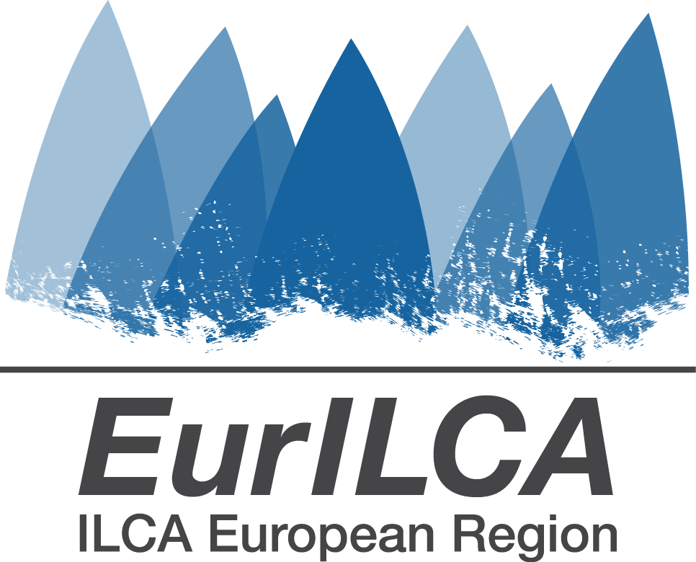

Please complete all areas on this form and return to EurILCA office : entryeurilca@gmail.com

EVENT NAME: | EurILCA Team Racing Regatta
VENUE:
PROPOSED DATES: | From: |  | To:
ALTERNATIVE DATES: | From: |  | To:

Organising Authority:

SAILING CLUB NAME:
ADDRESS:
WEBSITE:
EMAIL:

Logo of the club or event attached: | YES / NO

Regatta Organization responsible:
(Please give details of the contact nominated to receive information etc from EurILCA)

NAME: |  | FAMILY NAME:
TELEPHONE: |  | EMAIL:

Media contact person:
(Our Community manager will contact the media contact to get information after each racing day and to get pictures in order to post information and photos about the event on the EurILCA website and Facebook + other social media like Instagram)

NAME: |  | FAMILY NAME:
TELEPHONE: |  | EMAIL:

Entry procedures and Fees:
(Entries website procedures on https://eurilca.eu/team_racing/ will automatically when the regatta is created on line. Closing date at least 7 days before date of first race.

ENTRIES ONLINE CLOSING DATE:

ENTRY FEE *: |  | LATE ENTRY FEE *:

Details of what is included in the entry fee (e.g. social events, t-shirts, etc.):

Race Office:

Opening of Race Office first day, day and time:
Closing on the last day of racing, day and time:

Schedule:
(please give the regatta schedule including dates and times)

FIRST RACE |  | LAST RACE
Date | Time | Date | Time

ILCA 6 provided by the organisation:

ILCA 6 provided by the organisation: | YES or NO
If yes Minimum number of ILCA 6 available: |  | Fee:
Contact for boats:

Accommodation:
(Please give details of availability and address of camping, small hotels, etc., and cost per person per day. If insufficient room, please detail information on a separate sheet.)

Boat Landing Area and Facilities:
(Please give a description of the launching and landing facilities and if available provide plans / photographs of proposed site.)

Local Facilities:
(Please give a description of the facilities on-site, e.g. showers, refreshments toilets etc.)

Average Wind & Weather Conditions:
(Please give a brief description of the average wind strength and direction with any patterns in the weather for the dates of the event)

Local Driving Directions :

Tourist information :

Scoring system:
Is recommended to use free of charge ZW Scoring software
More information can be found on ZW Scoring software at http://www.zw-scoring.nl/

It be used ? | YES / NO

Agreement for the EurILCA Team Racing Series
The Appendix A: “Information how to organize ar EurILCA Team racing Regatta’s” is part of the agreement.
The Organizing Committee President and the local ILCA district chairman, or their representatives, have clearly read and understood the requirements in the guideline.

The Organizing committee is committed to comply the following procedures:

- Before the regatta

- To Nominate the Organizing Committee Contact Person. The Eurilca allows the OCCP to enter in the Eurilca website and upgrade the information about the regatta.
- To fully cooperate with the competent ILCA District
- To inform the Eurilca office about any issue rising on the regatta’s organization.
- To complete the sailing instructions template at least 3 weeks before the event
- To provide to Eurilca office the name and e.mail of the Team racing regatta Jury chairman and jury panel members and PRO at least one week before the event.
- Have contact with the Eurilca representative.

- During and After the event

- To cooperate with the EurILCA representative
- To check that all competitor have their World Sailing ID recorded in the scoring files.
- To upgrade results and provide daily reports to the Eurilca community manager and EurILCA office for the regatta records.
- To provide Eurilca the final rank results file immediately after the end of the event. The file must be as described in the Guideline, checked and affordable.

About the EurILCA representative expenses, it is taking care by the organisers for travel, lodging and food..

The Organizing Committee Representative takes the full responsibility to realize the event in line with the mentioned above Guideline once He/Her signs this agreement.

 |  | The Organizing Committee representative |  | The ILCA District Officer
Signature
Name
Role/position
Date

Full documentation and manuals available at http://eurilca.org/
Please return by email to: entryeurilca@gmail.com

